# **Philadelphia Food Desert Analysis**

Tim Wen, Lingxuan Gao

## 1 Introduction

A food desert is an area/neighborhood with restricted access to affordable, healthy food, such as fresh fruits and vegetables. (Whitacre et al., 2009) This is highly due to the limited numbers of grocery stores. These areas are correlated spatially with low-income urban and rural neighborhoods. Residents in food deserts are forced to switch to convenience stores or fast-food restaurants, causing potential serious health concerns and trapping them in the poverty cycle. As a result, it is important for the government to identify potential food deserts.

However, so far limited research has been done in the City of Philadelphia to identify food deserts. Especially after the pandemic, with the closure of a number of small businesses, more neighborhoods are likely to become food deserts

This project aims to use different spatial data and spatial analysis techniques to identify the neighborhoods under the potential threat of food deserts. Traditional definitions of food deserts often rely on simple classifications (e.g., “low-income household further than 1 mile from supermarket”). This project argues that food insecurity is influenced by:

1. Physical Distance: How far is the store?
2. Economic Access: Can residents afford the food?
3. Transportation: Can residents get to the store?
4. Systemic Barriers: Are there racial or historical disparities?

Our project explores these dimensions to identify Philadelphia’s most vulnerable neighborhoods.

## 2 Methodology

### 2.1 Spatial Analysis

To capture food access more accurately in Philadelphia, we opted for a high-resolution grid analysis over traditional spatial units like census tracts. This decision was made to increase the resolution of the results and specifically to account for intra-neighborhood spatial variations, which are often masked by larger census boundaries. We created a 50m x 50m vector grid covering the entire city of Philadelphia (approximately 1.5 million cells). The centroid of each cell was then calculated and used as the origin point for the subsequent network analysis.

### 2.2 Network Analysis

This project used OpenStreetMap street network from osmnx. Specifically, the traveling distances for each cell were calculated to both closest food store and closest USDA-authorized SNAP retailer.

### 2.3 The Composite Index

We developed a composite Food Desert Index (0-100) where higher scores indicate higher risk. The index is a weighted sum of four components. Due to the study’s aim to employ a comprehensive, multi-perspectival framework for risk identification, we consider these four components to be of equally critical importance in mapping Philadelphia’s food desert risk landscape. A community’s risk level is the integrated result of the interaction of these four dimensions, and a significant deficiency in ant one dimension is sufficient to place the community at high risk.

Therefore, in the initial modeling phase, we adopted an assumption of equal importance, assigning an equal weight (0.25) to each component to ensure the model’s balance and prevent subjective bias from over-emphasizing any single dimension.

$$Index=0.25×(Access)+0.25×(Economic)+0.25×(Transport)+0.25×(Demographic)$$

Physical Accessibility: Due to observed gap in OSM foodstore data, we weighted more on the SNAP data:

$$Access=0.3×(Food Store Dist.)+0.7×(SNAP Dist.)$$

Economic Vulnerability: Using ACS 2019-2023 Census data, economic condition was calculated as:

$$Econ=0.3×(Poverty)+0.25×(SNAP Rate)+0.25×(Unemployment)+0.2×(Inv.Income)$$

Transportation Barriers: Using both census and USDA Food Atlas data, transportation barrier was calculated as:

$$Trans=0.6×(HUNV Flag)+0.4×(Per no Vehicle)$$

Where HUNV Flag indicates tracts with low vehicle access >0.5 miles from a supermarket.

Demographic Disparities: Using census data, minority groups were calculated as:

$$Min=Percent Black+Percent Hispanic$$

Here is our process flowmap:

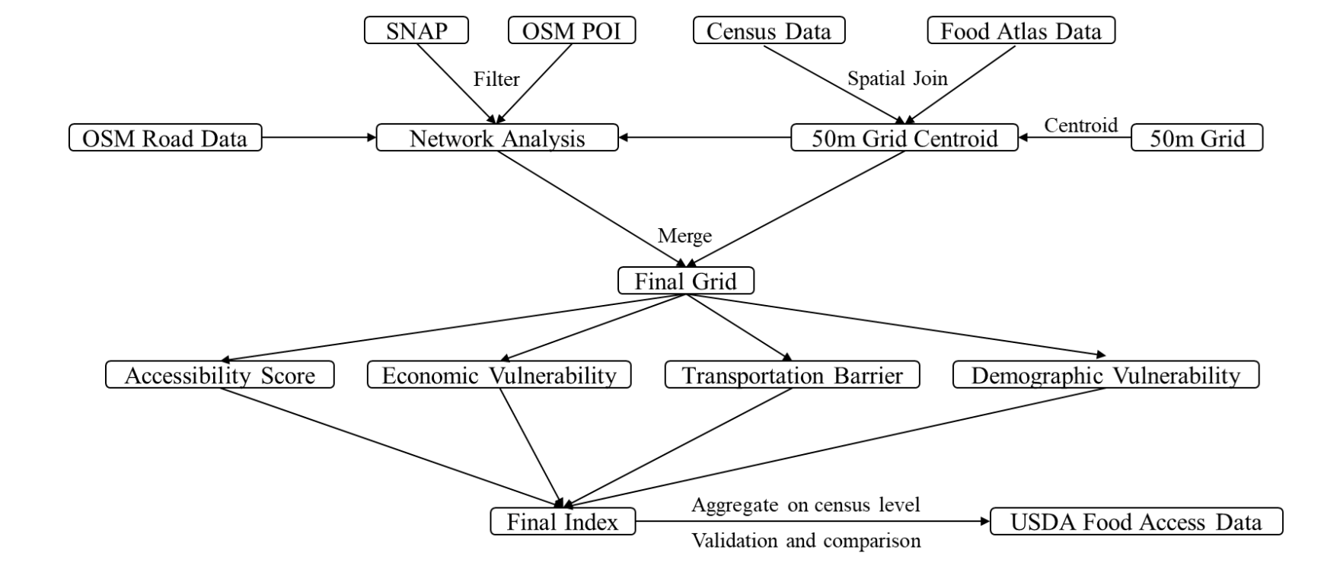

## 3 Results

### 3.1 Exploratory Data Analysis: Location of SNAP retailers and Food Store

Figure 1 shows the spatial distribution and density of SNAP retailers and food stores. The number of SNAP retailers is far more than that of food stores, highly due to the incomplete data caused by OSM data. The density is high in center Philly and West Philly, and very low in north especially far north east of Philadelphia, implying an uneven spatial distribution of food access.

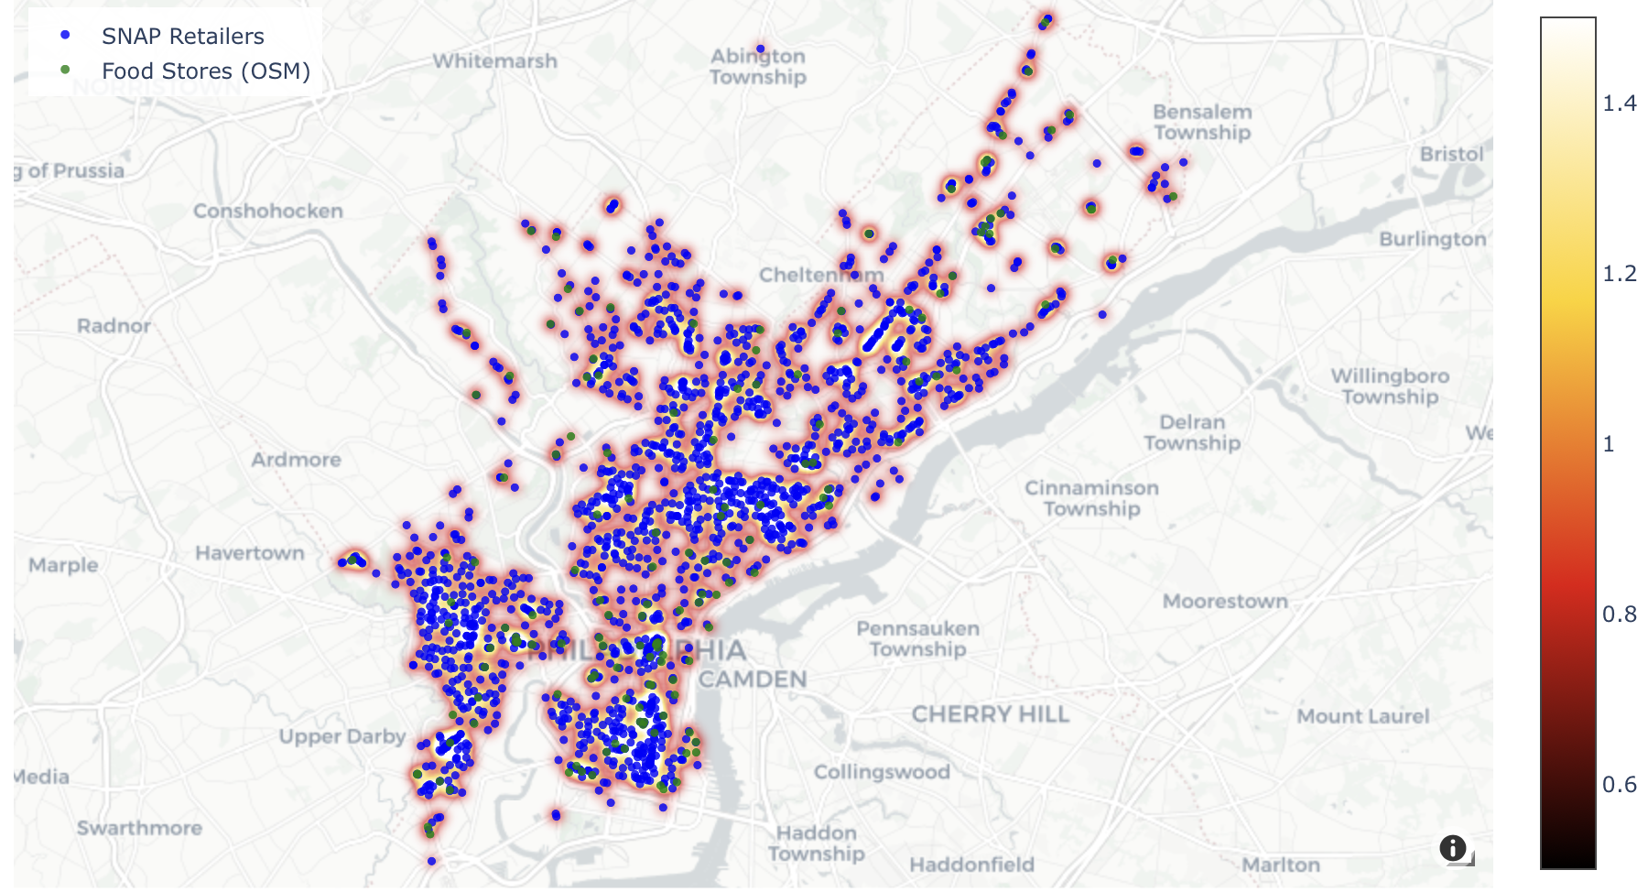

Figure 1: SNAP retailers and food store location map

### 3.2 Food Desert

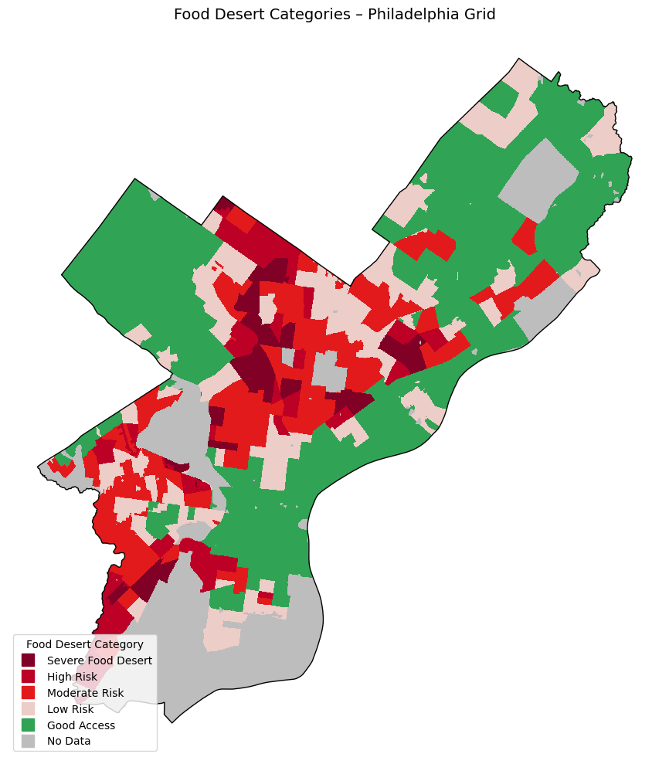

Figure 2: Food Desert Index map

Figure 2 displays the final Food Desert Index. Different from food access density map, West and North Philadelphia had higher risk score. While far north east of Philadelphia, with extreme low economic vulnerability and transportation barrier, have the ability to either order food online or drive to buy fresh food. This shows the advantage of our approach, as we analyze and identify from muti-perspectives.

### 3.3 Risk Drivers

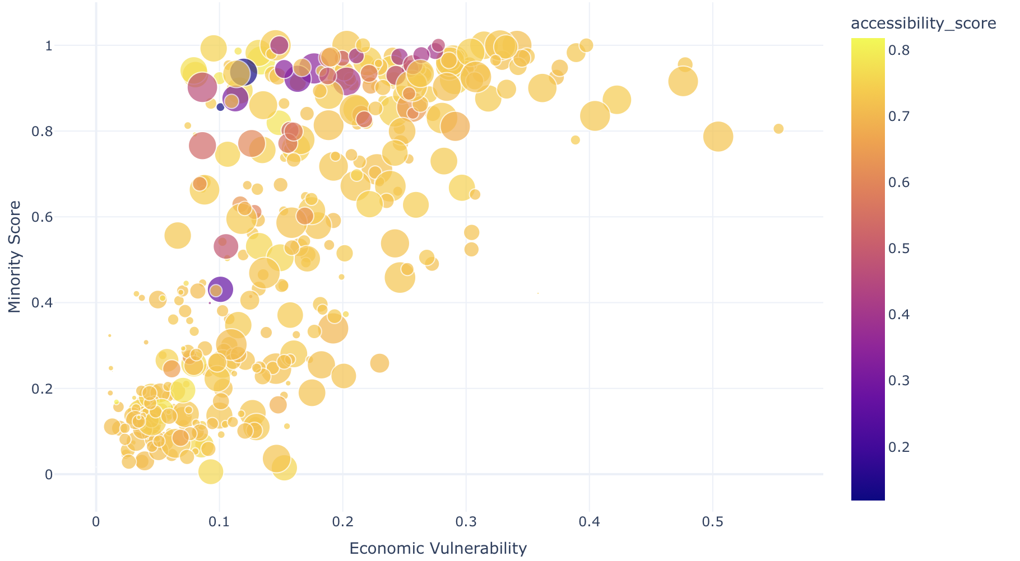

Graph 1: Risk drivers visualization

Graph 1 shows the correlation between four components that make up our index: economic vulnerability, minority score, accessibility score and transportation barrier. First, there is a positive relationship between economic vulnerability and minority score, as there are more minority groups within the census tract, the economic condition becomes more vulnerable. Moreover, more bigger and darker dots are clustered at high minority score area, implying minorities are more suffered by inconvenient transportation to food stores.

### 3.4 USDA comparison

To further examine the accuracy of our approach, we use data from USDA to compare our results. Specifically, USDA data use classified census tract that at least 100 households do not own a vehicle and supermarket is at least 0.5 miles away as a flag. Although this data is used in our approach as well, and it is only updated to 2019, it still reflect food access in Philadelia to some extent.

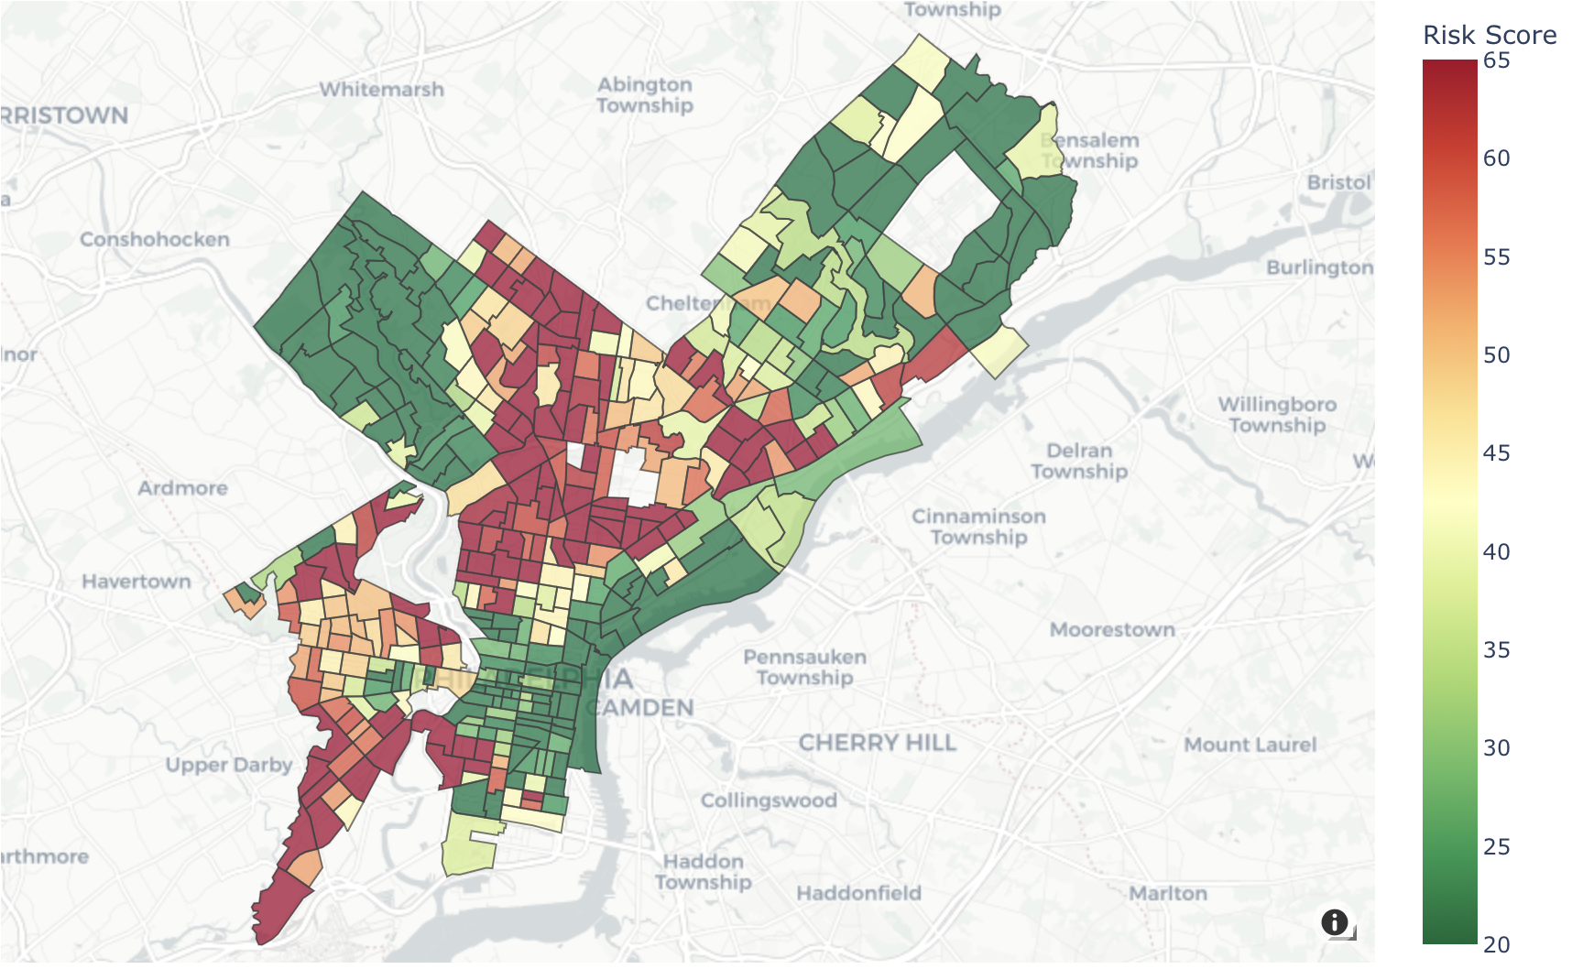

地图

AI 生成的内容可能不正确。

Figure 3 and 4: Food Desert map based on USDA definition

As Figure 3 and 4 show, the general pattern of both maps are similar, with a cluster of potential food desert on north, northeast, and southwest of Philadelphia. Interestingly, tracts on the far north of Philadelphia have a low-risk score, while they were classified as potential food desert by USDA data. This is because the economic vulnerability score is very low in those tracts. As the USDA data is from 2019, this may be due to recent gentrification, increasing the economic level of the tract.

## 4 Conclusion

This project used a muti-dimensional approach to estimate the potential food desert in Philadelphia. We considered food desert as a comprehensive issue with transportation, economy and race. Based on this, four components were used to calculated the final food desert risk index. South-west and North Philadelphia were identified as potential food desert. We also compared our results with USDA food atlas data. The pattern was similar except north-east of Philadelphia, as our method no longer identified them food desert because low economic vulnerability.

However, there are several limitations to the study, first, the OSM POI data is incomplete. To compensate, our index highly weighted SNAP retailer data (70%). Moreover, the network analysis only utilized the driving network topology. While this accounts for physical road connectivity, it does not capture the specific challenges of pedestrians (e.g., sidewalk availability, safety) or public transit users (e.g., bus frequency, transfers). Especially in Philadelphia, a significant portion of the high-risk population relies on non-automotive transport, a driving-based metric may underestimate the true time-cost of accessing food.

Future research could address these issues by a more comprehensive method. For example, not only food access, but also health food access should be considered in the model. A “Healthy Food Availability Index” (HFAI) to weight stores based on the actual provision of fresh fruits and vegetables rather than treating all SNAP retailers equally could be used in future model. Moreover, a muti-modal network analysis accounting both walk, and public transportation would better represent the experience of car-less households

## 

## References

Whitacre, Paula, Peggy Tsai, Janet Mulligan, Board on Population Health and Public Health Practice, Food and Nutrition Board, and Board on Agriculture and Natural Resources. 2009. *The Public Health Effects of Food Deserts: Workshop Summary*. Edited by Paula Whitacre, Peggy Tsai, and Janet Mulligan. N.p.: National Academies Press.